CREATE OR REPLACE PROCEDURE StoredProc()

RETURNS VARCHAR NOT NULL

LANGUAGE JAVASCRIPT

EXECUTE AS CALLER

AS

$$

var my_sql_command ="CREATE OR REPLACE DATABASE STORED_PROCEDURE";

snowflake.createStatement({sqlText:my_sql_command}).execute();

var my_sql_command1 ="CREATE OR REPLACE SCHEMA external_staging";

snowflake.createStatement({sqlText:my_sql_command1}).execute();

snowflake.createStatement({sqlText:`CREATE OR REPLACE STAGE AWSD url='s3://my-aws-s3-bucket-vdasari21/ProjectFiles/Final_NBA_Data.csv'

credentials=(aws_key_id='' aws_secret_key='');`}).execute();

snowflake.createStatement({sqlText:`create or replace table nba_player_stats (

PLAYER_ID INT,

RANK INT,

PLAYER VARCHAR,

TEAM_ID BIGINT,

TEAM VARCHAR,

GP FLOAT,

MIN FLOAT,

FGM FLOAT,

FGA FLOAT,

FG_PCT FLOAT,

FG3M FLOAT,

FG3A FLOAT,

FG3_PCT FLOAT,

FTM float,

FTA float,

FT_PCT FLOAT,

OREB FLOAT,

DREB FLOAT,

REB FLOAT,

AST FLOAT,

STL FLOAT,

BLK FLOAT,

TOV FLOAT,

PTS FLOAT,

EFF FLOAT

);`}).execute();

snowflake.createStatement({sqlText:`copy into nba_player_stats from

@STAGINGS.EXTERNAL_STAGING.AWS file_format = (type='csv' field_delimiter=',' skip_header=1);`}).execute();

return "Success";

$$;

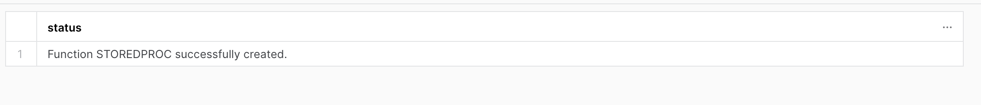

#Retrieve all data from the table

SELECT * FORM nba_player_stats;

Explanation:

1. We have created a stored procedure with name "StoredProc"

2. This stored procedure returns a string VARCHAR

3. We have given caller rights for this stored procedure

4. In the above stored procedure, we have done the following:

1. Created Database STORED_PROCEDURE

2. Created Schema external_staging

3. Created Stage with AWS s3

4. Created table nba_player_stats with columns matching the data in S3.

5. Copied data from stage into table

6. Retrieve data from the table